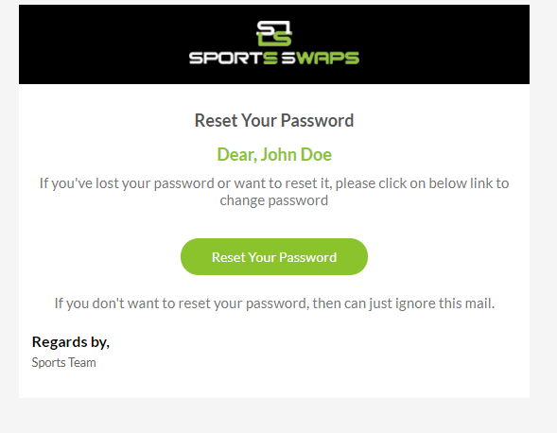

Dear, (username)

This email was sent in response to your request to reset your account password. If you did not submit this request, please ignore this email.

To reset your password, please click on the link below:

The link will be active for 24 hours only. If you continue to experience problems while trying to login to your account, please contact our customer service email address at [cs@sportsswaps.eu](mailto:cs@sportsswaps.eu)

Best Regards,

SportsSwaps